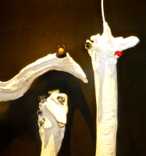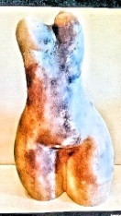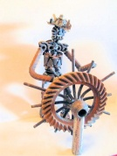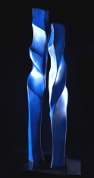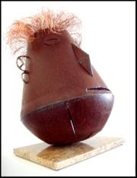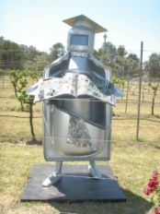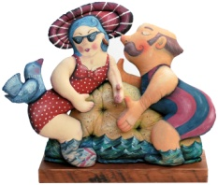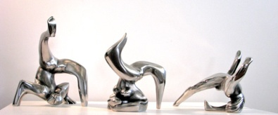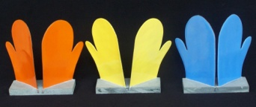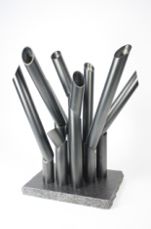 PRESENTED by the SCULPTORS SOCIETY 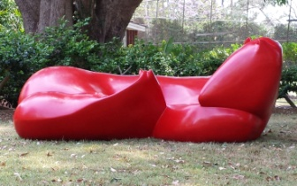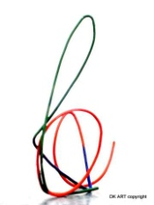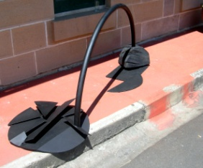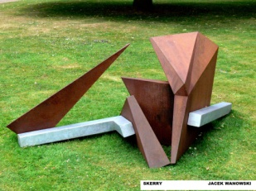

Acknowledgement

Willoughby Council (as per requirements)

TBA

**For further information please contact**

**THE SCULPTORS SOCIETY**

[**www.sculptorssociety.com**](http://www.sculptorssociety.com/)[**sculpt1@bigpond.net.au**](mailto:sculpt1@bigpond.net.au)

**FEYONA van STOM** [**feyonavanstom@gmail.com**](mailto:feyonavanstom@gmail.com)

**MARYANN NICHOLLS** [**nichom@bigpond.net.au**](mailto:nichom@bigpond.net.au)

**WORKS FEATURED**

**EYE-EYE-EYE – ANGELA MORRELL**

**TORSO – FEYONA van STOM**

**SEA CAPTAIN – WILLEM van STOM**

**COPPER 2 – MARGARET SHERIDAN**

**OCEANIA – VREJ MATOSSIAN**

**THE FORBIDDEN HERO - NIKI BLAZESKA**

**ROMANCE - LOLA KAPLAN**

**GRAFFIT MOONSTRIKE - PETER LEWIS**

**HOTT MITTS - SALLY APLIN**

**AFTER THE HARVEST – LEE BLATTMANN**

**RED MARE AND FOAL – MARYANN NICHOLLS**

**LOVE – DENNIS KALOUS**

**TRANSITION – MAURICE SCHESINGER**

**SKERRY – JACEK WANKOWSKI**

Contributing sculptors

cathie alexander

patricia anderson

sally aplin

lee blattmann

niki blazeska

john brooke

irene carroll

meike davis

phillipa graham

jenny green

argo ho

jan hursop ////?????

dennis kalous

lola kaplan

helen leete

peter lewis

vivienne lowe

vrej matossian

angela morrell

maryann nicholls

feisal ramadan

carolyn rendle

kathy rosenmeyer

maurice schesinger

ian scott

jan howard-shaw

margaret sheridan

rona sissons

david solomon

larissa smagarinsky

alan somerville

roz stampfli

petra svoboda

feyona van stom

willem van stom

jacek wankowski

margaret westcott